PROJECT WORK

# PROJECT TITLE: - Comprehensive Digital Marketing For Noise

# NAME :- V.Fahemina Batool

# GROUP: - B. Com Computer Applications

# COLLEGE: - Vasavi Mahila Kalasala

# UNIVERSITY: - Rayalaseema University

# MENTOR: - Gudisepogu Maneesha

# TEAM ID: - LTVIP2025TMID21797

INTRODUCTION

In Today’s Digital Marketing refers to the online channels, tools, and strategies to promote products, services, or brands.

## It includes various forms such as social media marketing, search engine

## Optimization (SEO), email marketing, content marketing, and paid

## Advertising.

## Unlike traditional marketing (TV, RADIO, PRINT), digital marketing allows

## For precise audience, and personalized engagement.

**Digital Marketing: The Modern Approach to Promotion**

In today's world, **digital marketing** refers to using online channels, tools, and strategies to promote products, services, or brands. It encompasses various forms such as **social media marketing**, **search engine optimization (SEO)**, **email marketing**, **content marketing**, and **paid advertising**.

Unlike traditional marketing methods like **TV**, **radio**, and **print**, digital marketing offers the advantage of more targeted, personalized audience engagement. This allows businesses and brands to reach specific groups with tailored messages based on real-time data and

Interactions.

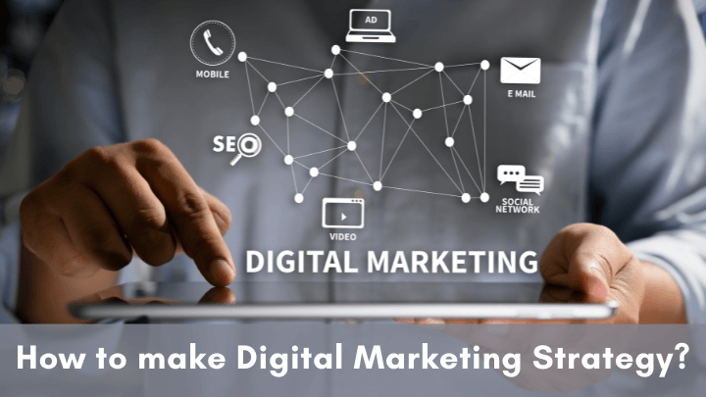

**Key Components of Digital Marketing**

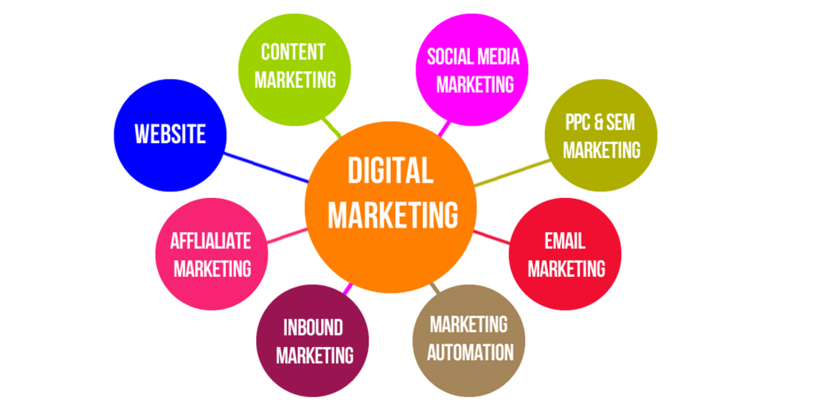

1. **Search Engine Optimization (SEO)**  
   SEO involves optimizing content and websites to rank higher in search engine results, improving visibility and attracting organic traffic.
2. **Content Marketing**  
   Creating and distributing valuable content (blogs, videos, infographics) to attract and engage an audience while driving profitable customer actions.
3. **Social Media Marketing (SMM)**  
   Using platforms like Facebook, Instagram, and Twitter to build brand awareness, drive website traffic, and engage with followers.
4. **Pay-Per-Click Advertising (PPC)**  
   Paying for ads that appear on search engines or social media platforms, where businesses only pay when a user clicks on their ad.
5. **Email Marketing**  
   Sending targeted emails to nurture leads, build relationships with customers, and drive conversions.

**Digital Marketing for the Noise Industry**

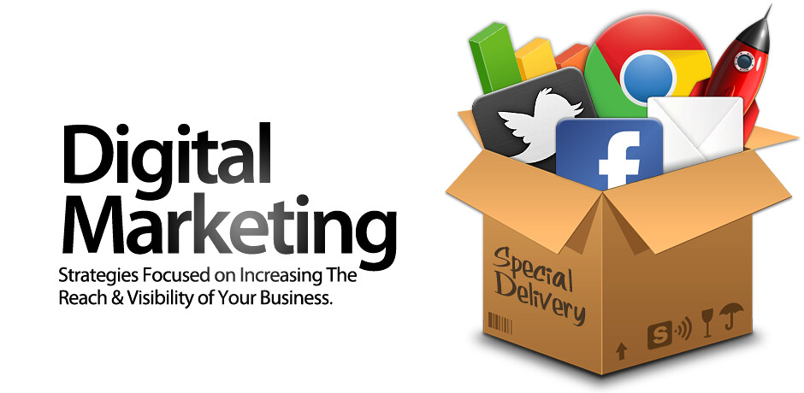

In the noise, entertainment, or music industry, digital marketing plays a crucial role in expanding reach, building brand awareness, and engaging directly with fans and listeners. For musicians, producers, or audio-related brands, **digital marketing** is essential for standing out in a highly competitive environment.

**Advantages of Digital Marketing for Noise**

* **Targeted Advertising**: Allows brands to reach specific demographics, such as music lovers or industry professionals.
* **Global Reach**: Breaks geographical boundaries, enabling promotions to reach global audiences through platforms like YouTube, Spotify, and social media.
* **Cost-Effective**: Compared to traditional advertising, digital marketing strategies like social media promotions and SEO are often more affordable.
* **Real-Time Analytics**: Marketers can track performance in real time, adjusting campaigns to improve results instantly.

**Disadvantages of Digital Marketing for Noise**

* **Saturation**: The digital space can be overcrowded, making it difficult to stand out without significant effort and creativity.
* **Dependence on Algorithms**: Social media platforms and search engines continuously change their algorithms, affecting visibility.
* **Technical Skills Required**: Implementing effective strategies often requires expertise in SEO, analytics, and ad management, which can be overwhelming for some brands.

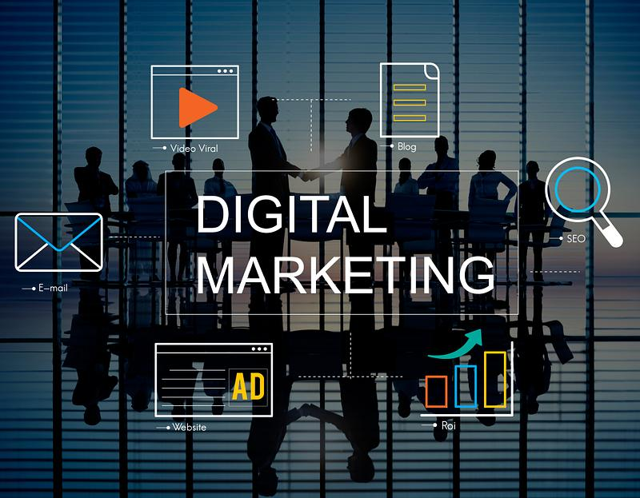

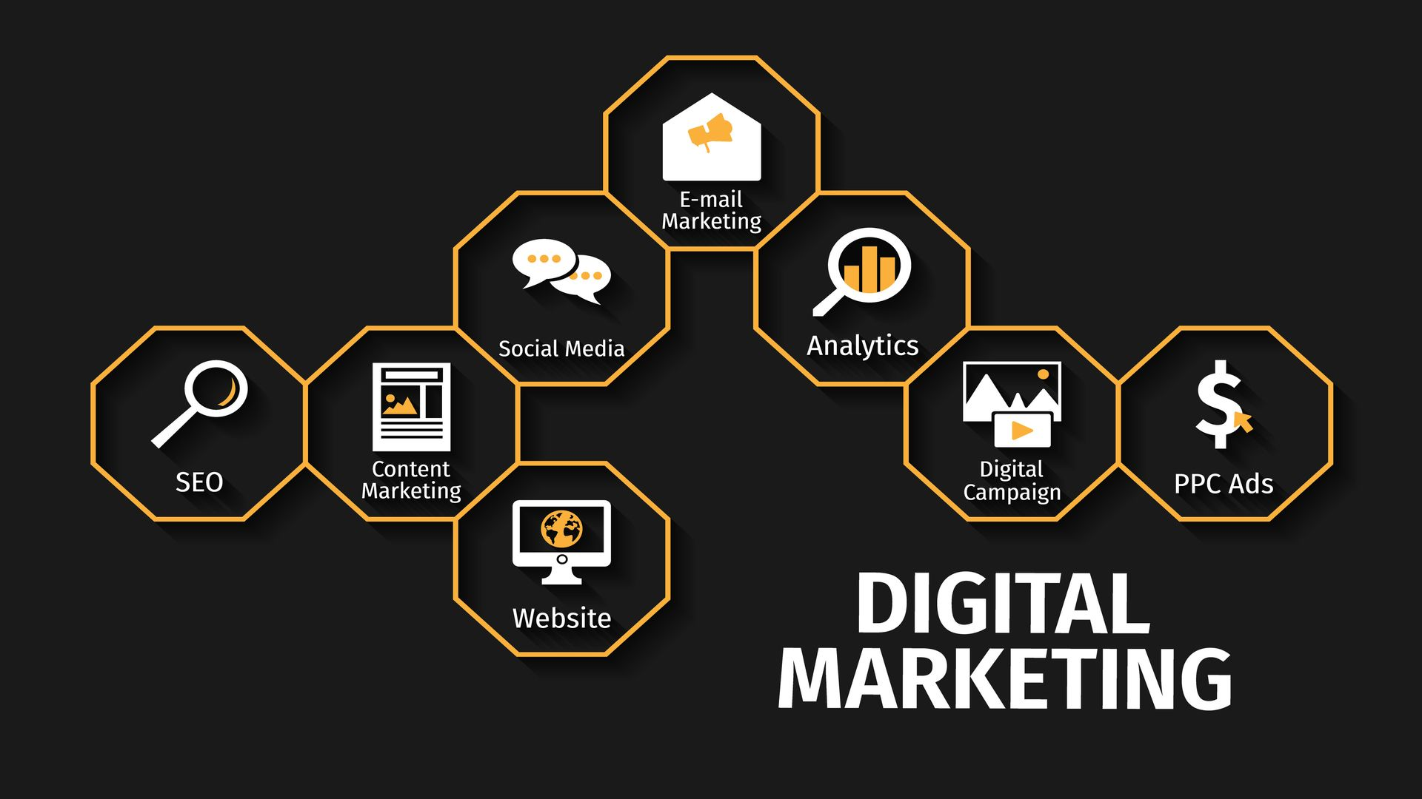**Comprehensive Digital Marketing for Noise**

For a comprehensive digital marketing approach for the noise or music industry, businesses need to employ a mix of strategies to build a presence. Here’s a holistic approach:

* **Content Strategy**: Share engaging content such as music releases, behind-the-scenes footage, interviews, and live performances.
* **SEO**: Optimize content on platforms like YouTube, Spotify, and music blogs to ensure high visibility for relevant searches.
* **Social Media Engagement**: Interact directly with fans, promote new releases, and create a community through active engagement on platforms like TikTok, Instagram, and Twitter.
* **Influencer Partnerships**: Collaborate with influencers in the entertainment space to promote your brand or music.
* 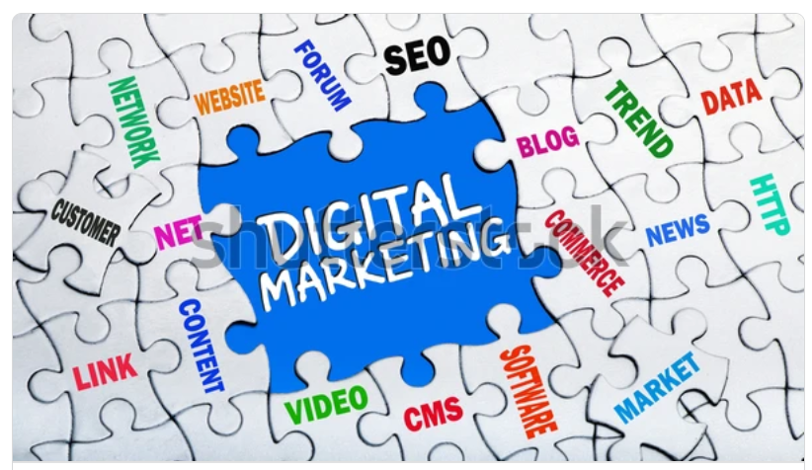**Paid Advertising**: Invest in PPC ads to promote events, music releases, or merchandise, driving traffic to your website or streaming platforms.

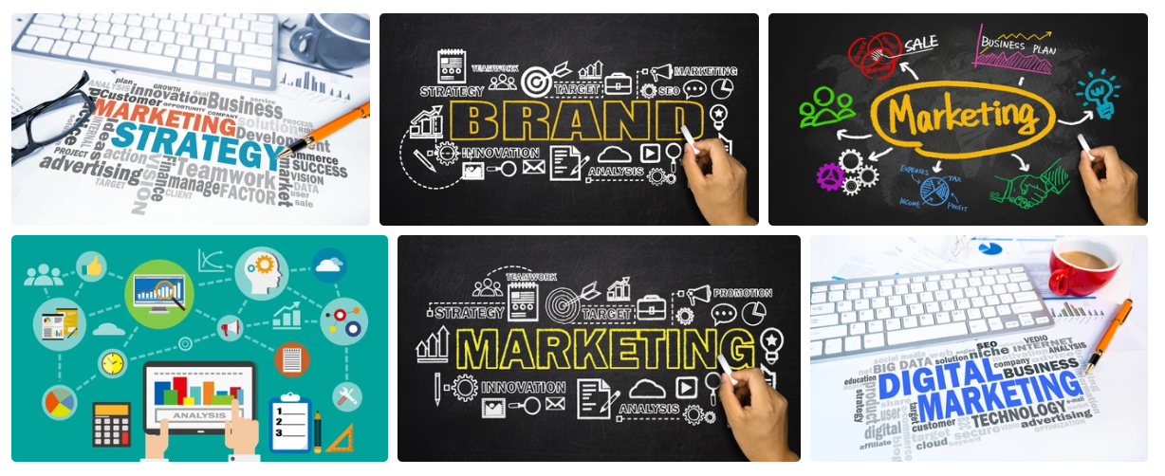

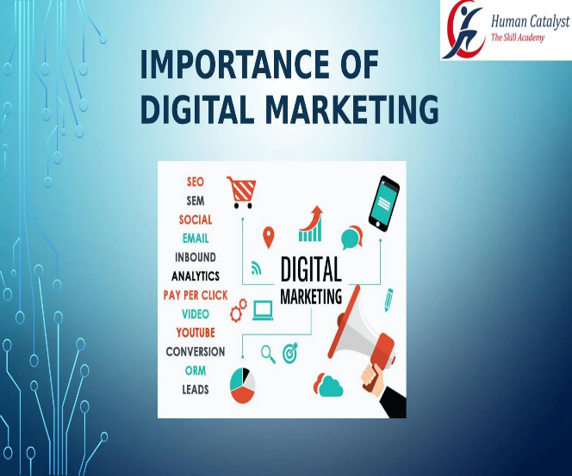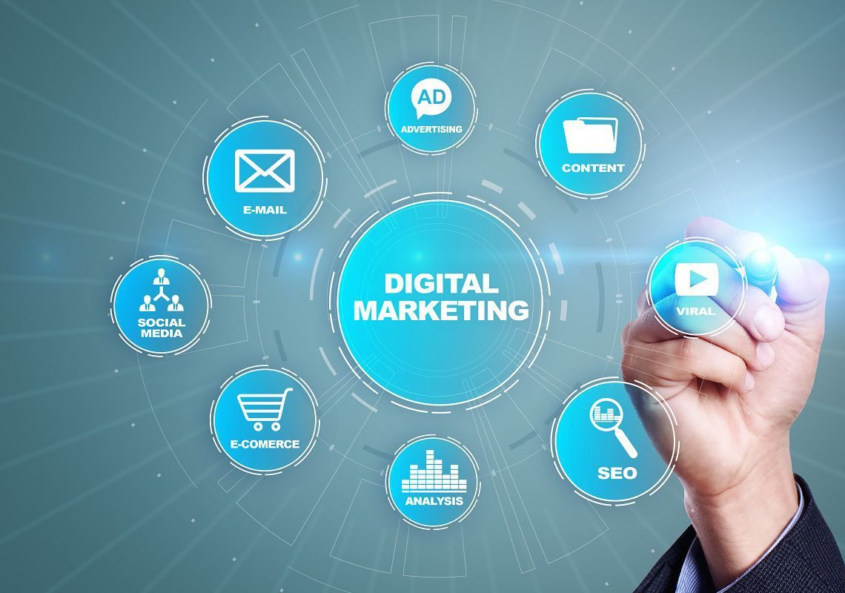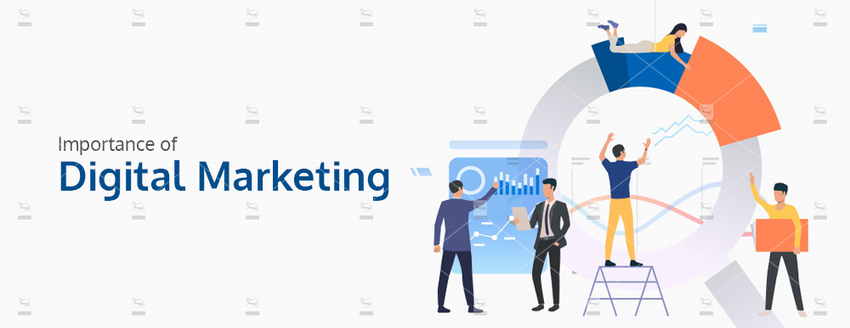**Importance of Digital Marketing for Noise**

In a rapidly evolving digital landscape, the importance of digital marketing for the noise or entertainment industry cannot be overstated. Digital marketing allows artists, brands, and companies to:

* Build **direct connections** with their audience.
* Increase **visibility** across platforms.
* Amplify **sales and engagement** through paid promotions.
* 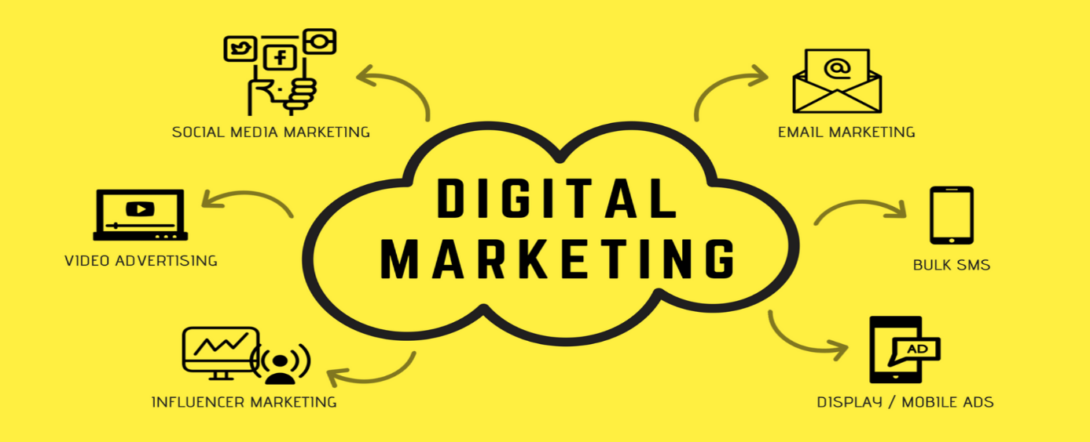Measure **ROI** and adapt marketing strategies based on performance data.

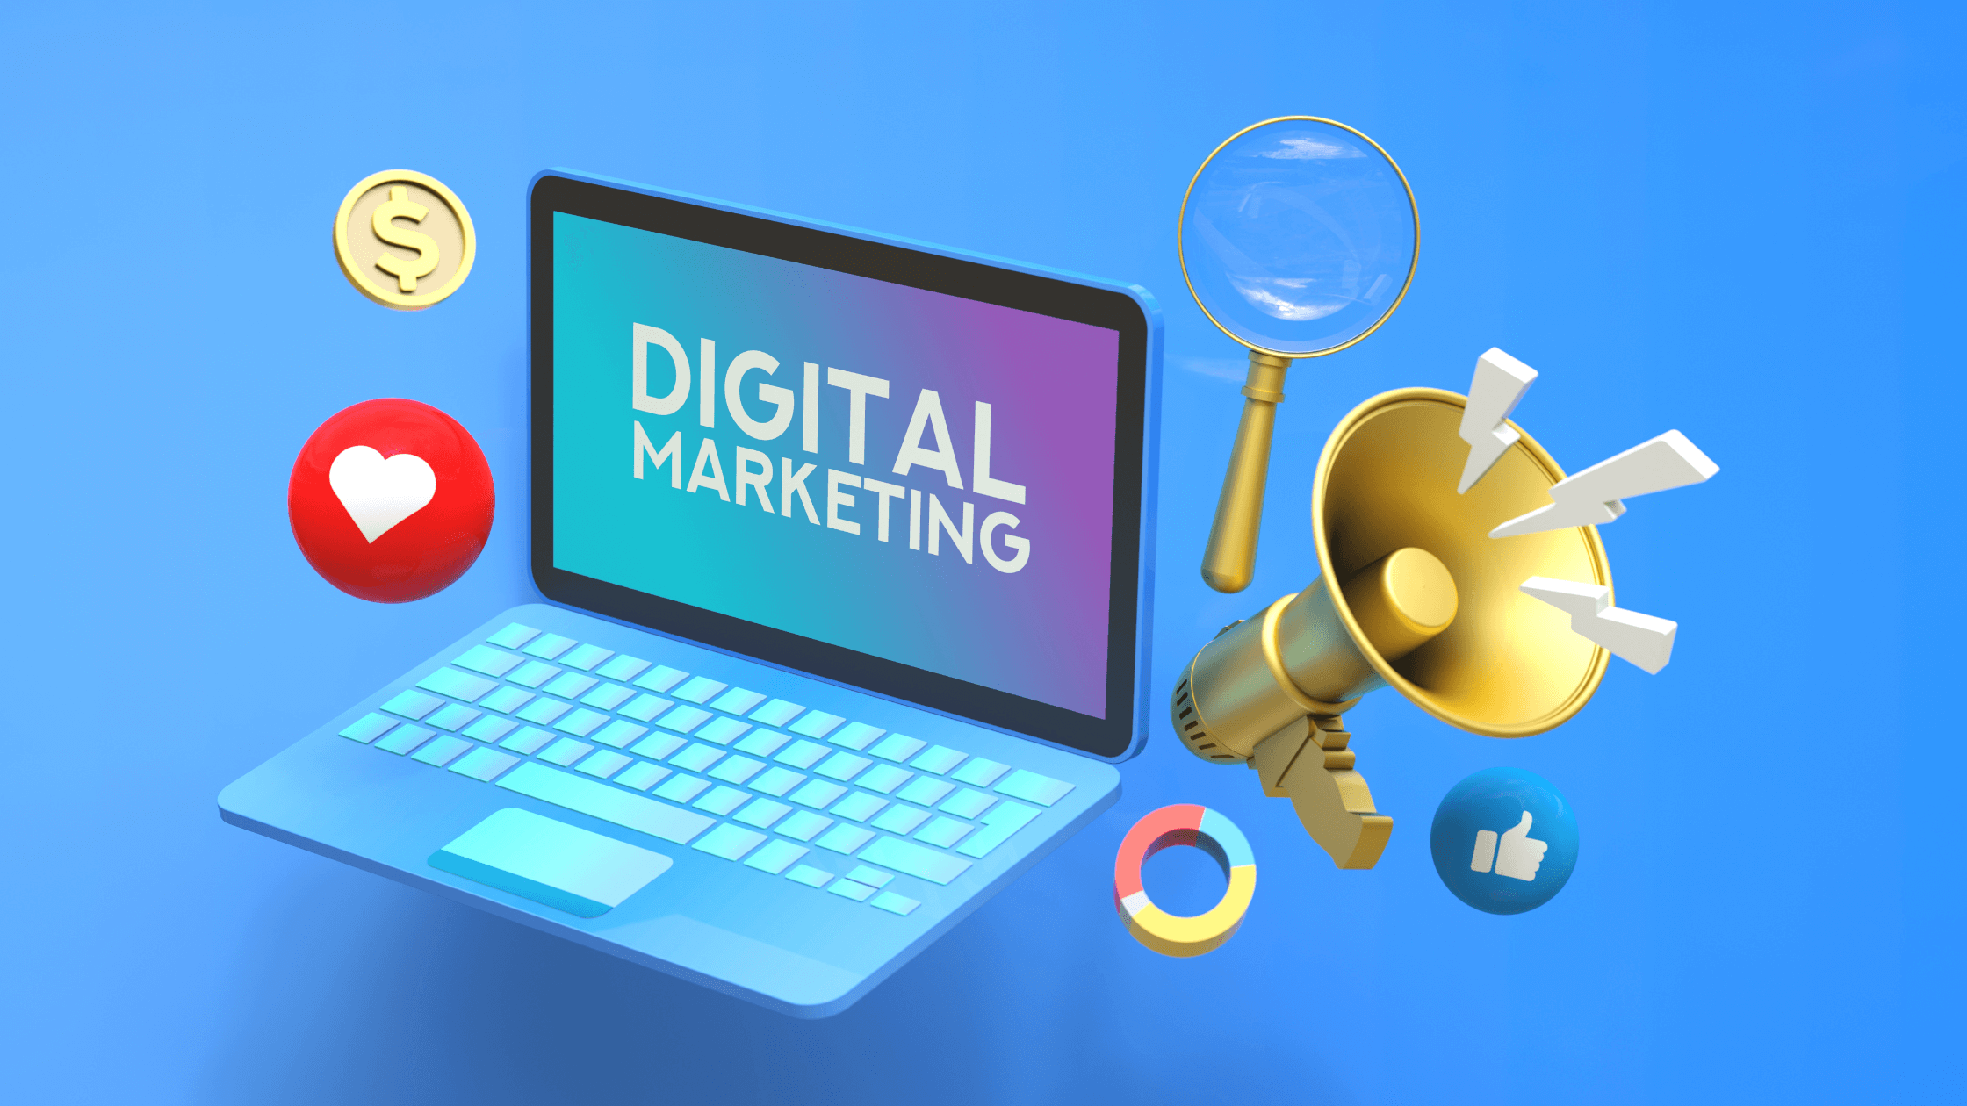

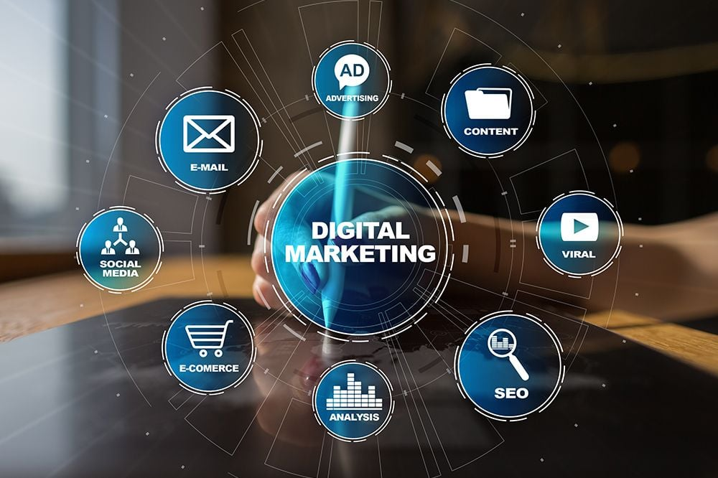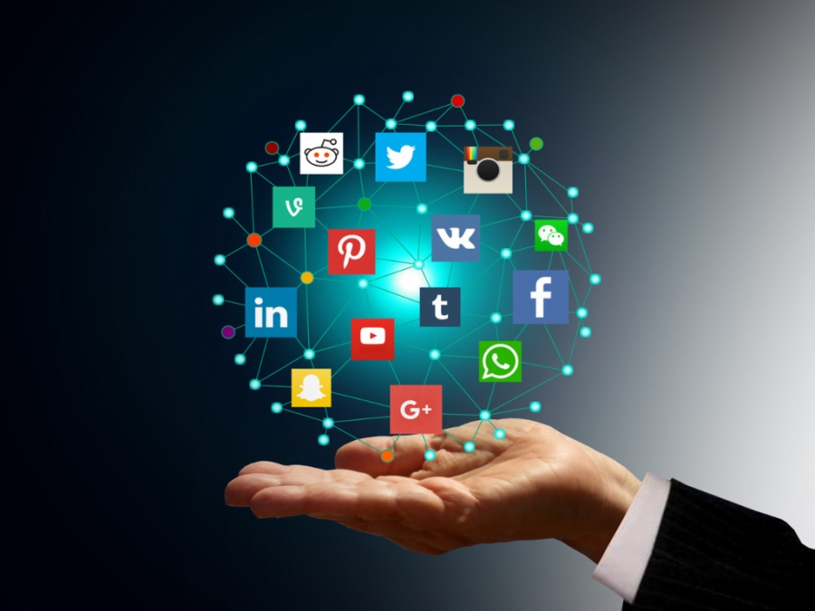

Without leveraging digital marketing, the potential for growth and visibility within the competitive world of entertainment or noise-related industries is significantly limited.

**Conclusion**

Digital marketing has become an essential tool for businesses across all industries, including the noise, music, and entertainment sectors. It offers a cost-effective, targeted approach to reaching audiences, driving engagement, and measuring results. By utilizing a combination of strategies like SEO, content marketing, social media, and paid advertising, brands can expand their reach, enhance visibility, and foster stronger connections with their audience. As digital platforms continue to evolve, the importance of adapting marketing strategies to these changes is crucial for maintaining competitive edge. Ultimately, digital marketing provides endless opportunities for growth, innovation, and success in the fast-paced digital age.